PROJECT REPORT
Women's Clothing
Trends and Analysis in the Fashion Industry
Detection and Treatment of Numerical Outliers using IQR, Z-score and DBSCAN
Report detail | Value
Prepared by | Harsh Panchal
Dataset | Women's E-Commerce Clothing Reviews (Kaggle)
Analysis scope | Age and Positive Feedback Count
Report date | 22 August 2026

Academic data-cleaning and exploratory analysis project

Executive Summary
This project examined numerical outliers in a women's clothing e-commerce review dataset. Three complementary methods were applied: the Interquartile Range (IQR), Z-score and DBSCAN clustering. The analysis separated statistical rarity from data error and used domain knowledge to decide whether extreme values should be retained, transformed, capped or removed.
Key outcome | Result
Original records | 23,486
Exact duplicates removed | 21
Final unique records | 23,465
Invalid numerical records | 0
Age treatment | Retained; extreme ages were valid
Feedback treatment | log1p transformation; original retained
Feedback skewness | 6.47 to 1.09

Overall conclusion: No outlier record was removed because the extreme numerical values were plausible in the business context. Twenty-one exact duplicate records were removed separately, leaving 23,465 unique observations.

1. Project Overview

1.1 Project title
Women's Clothing: Trends and Analysis in the Fashion Industry

1.2 Assigned task
Deal with outliers in numerical columns by applying multiple detection methods (IQR, Z-score and DBSCAN clustering) and decide case-by-case whether to cap, transform or remove extreme values using domain-specific insights.

1.3 Objectives
- Identify the numerical columns where outlier analysis is meaningful.
- Detect extreme observations using univariate and multivariate methods.
- Compare method sensitivity and agreement instead of relying on a single rule.
- Protect genuine customer and engagement information from unnecessary deletion.
- Produce a cleaned dataset and an auditable record of detection decisions.

2. Dataset Description
The dataset contains customer reviews and ratings for women's clothing products. It was obtained from Kaggle and contains review text, product identifiers, customer age, ratings, recommendation status, feedback counts and product hierarchy fields.
Dataset attribute | Observed value
Rows in source file | 23,486
Columns in source file | 11
Rows after duplicate removal | 23,465
Customer age range | 18 to 99 years
Rating range | 1 to 5
Positive feedback range | 0 to 122

2.1 Numerical-column classification
Column | Data role | Outlier analysis | Reason
Age | Continuous/ordinal measure | Yes | Unusual ages may be statistically extreme.
Positive Feedback Count | Non-negative count | Yes | Highly skewed engagement measure.
Rating | Fixed scale (1-5) | Range validation | Extreme valid ratings are meaningful.
Recommended IND | Binary (0/1) | No | Binary values do not have continuous outliers.
Clothing ID | Identifier | No | Identifier magnitude has no analytical meaning.

3. Data Preparation
The source column 'Unnamed: 0' was a unique row index and was removed because it had no analytical meaning. After removing this artificial identifier, 21 exact duplicates became visible. Keeping the index would have incorrectly made every row appear unique. One copy of each duplicate was retained.
Preparation step | Action/result
Remove artificial index | Dropped 'Unnamed: 0'
Duplicate treatment | 21 repeated rows removed; first occurrence retained
Missing-value check | No missing values in Age or Positive Feedback Count
Domain validation | No invalid age, rating, recommendation or negative feedback values

4. Outlier Detection Methodology

4.1 Interquartile Range (IQR)
IQR is a robust univariate method that does not require normally distributed data. For each target column, Q1 and Q3 were calculated, followed by IQR = Q3 - Q1. Values below Q1 - 1.5(IQR) or above Q3 + 1.5(IQR) were flagged.
Column | Q1 | Q3 | Lower limit | Upper limit | Outliers
Age | 34.0 | 52.0 | 7.0 | 79.0 | 109
Positive Feedback Count | 0.0 | 3.0 | -4.5 | 7.5 | 2,147

4.2 Z-score
The Z-score expresses each value as its distance from the mean in standard-deviation units. Records with |Z| > 3 were flagged. This method is most interpretable for approximately normal data and was therefore treated cautiously for the strongly right-skewed feedback count.

4.3 DBSCAN clustering
DBSCAN provided multivariate detection by examining Age and Positive Feedback Count together. Features were standardized, then DBSCAN was run with eps = 0.5 and min_samples = 5. Label -1 represented sparse observations (noise) rather than automatically invalid records.

5. Detection Results
Method | Analysis target | Detected records | Percentage
IQR | Age | 109 | 0.46%
Z-score | Age | 99 | 0.42%
IQR | Positive Feedback Count | 2,147 | 9.15%
Z-score | Positive Feedback Count | 430 | 1.83%
DBSCAN | Age + feedback | 50 | 0.21%

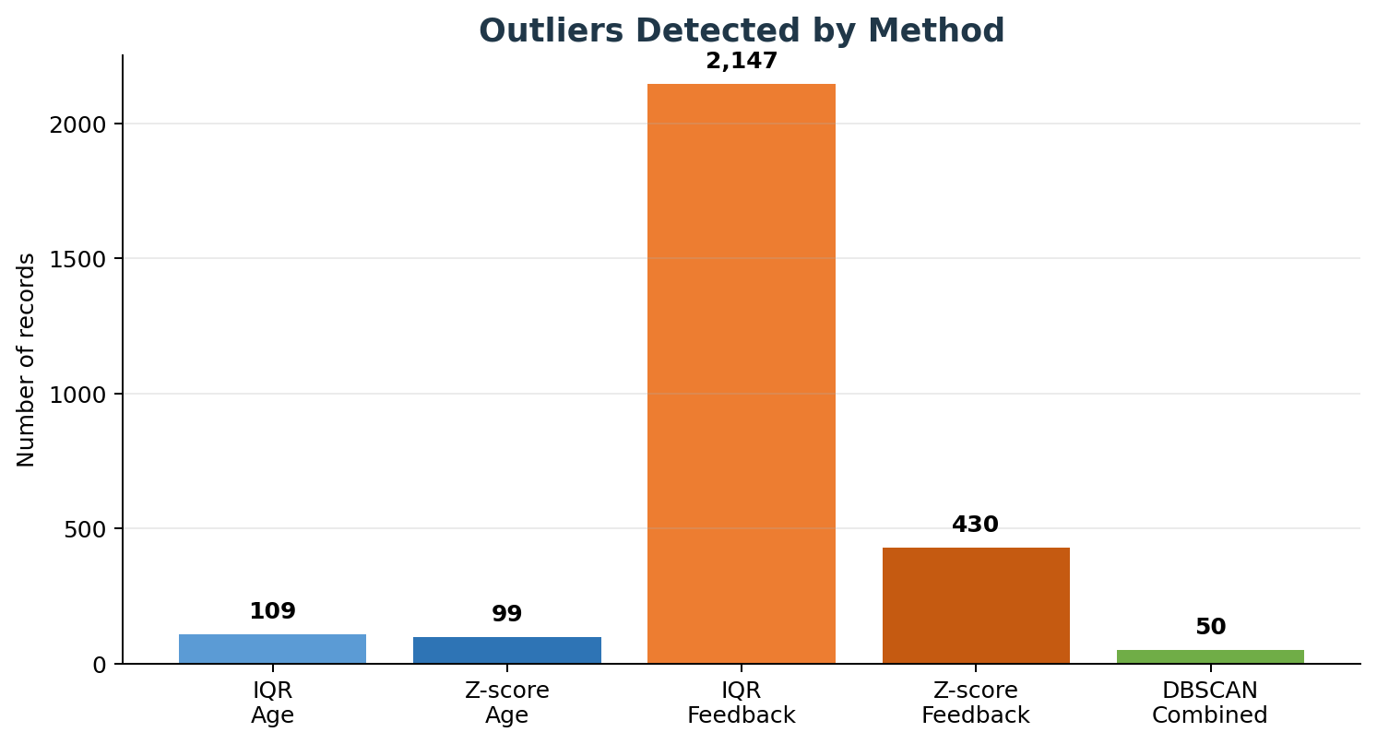
Figure 1. Number of outliers detected by each method.

5.1 Comparison and method agreement
For Age, the methods closely agreed: IQR flagged 109 observations (ages 80-99), while Z-score flagged 99 observations (ages 81-99). For feedback, IQR was much more sensitive, flagging counts of 8 or more, whereas Z-score primarily captured the most extreme counts of 20 or more. DBSCAN detected 50 unusual age-feedback combinations, almost all driven by very high feedback.

6. Case-by-Case Treatment Decisions
Column/record type | Decision | Domain-specific rationale
Age | Keep | 18-99 is a plausible customer-age range. Capping would distort real ages; removal would exclude valid older customers.
Positive Feedback Count | Transform | High counts can represent genuine review popularity. log1p reduces influence while preserving values and ordering.
Rating | No treatment | All values are valid on the fixed 1-5 scale.
Recommended IND | No treatment | All values are valid binary indicators (0/1).
DBSCAN noise | Flag and retain | Density-based noise indicates rarity, not confirmed error.
Invalid records | Remove if present | The rule was implemented, but zero invalid numerical records were found.

6.1 Why capping was not selected
Winsorizing feedback at a percentile boundary would replace genuine engagement counts with artificial limits. Because the analysis needed to preserve review popularity, log transformation was chosen over capping. The original feedback column was retained alongside the transformed feature for interpretability.

7. Transformation and Validation
The new feature Positive Feedback Log was created as log(1 + Positive Feedback Count). The use of log1p safely handles zero counts and compresses the long right tail without deleting or changing the source field.
Validation measure | Result
Original feedback skewness | 6.47
Log-transformed skewness | 1.09
Original maximum | 122
Transformed maximum | 4.81
Missing transformed values | 0
Infinite transformed values | 0

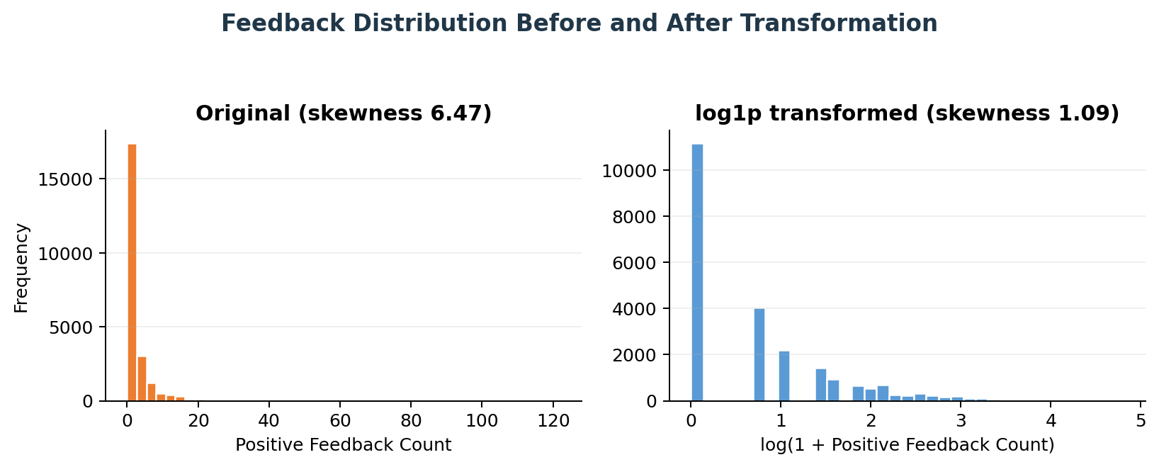
Figure 2. Positive-feedback distribution before and after log1p transformation.

8. Final Data Quality Status
Quality check | Final result
Final rows | 23,465
Remaining exact duplicates | 0
Invalid ages | 0
Negative feedback counts | 0
Invalid ratings | 0
Invalid recommendation values | 0
Records removed as outliers | 0
Data retained after duplicate removal | 99.91%

9. Key Findings
- Statistical outliers are not automatically data errors; domain interpretation materially changed the treatment decision.
- Age outliers represented plausible older customers and were retained to avoid demographic bias.
- Positive Feedback Count was strongly right-skewed, making IQR substantially more sensitive than Z-score.
- DBSCAN identified rare multivariate patterns, but these records were mainly genuine high-engagement reviews.
- Log transformation reduced feedback skewness from approximately 6.47 to 1.09 without removing information.
- Removing the artificial row index revealed 21 exact duplicates that were then safely removed.

10. Limitations and Recommendations
- DBSCAN results depend on eps and min_samples; parameter sensitivity should be documented when the model is reused.
- Review age and feedback outliers periodically if new data extends the current observed ranges.
- Use Positive Feedback Log in statistical models, clustering or visualization, while keeping the original count for reporting.
- Do not apply a single universal outlier rule to identifiers, binary variables, ratings and continuous/count variables.
- If business metadata such as review date becomes available, assess whether very high feedback is explained by review age or exposure time.

11. Conclusion
The project successfully applied IQR, Z-score and DBSCAN to the relevant numerical fields in the women's clothing review dataset. IQR and Z-score detected unusual ages and feedback counts, while DBSCAN identified rare age-feedback combinations. Domain validation showed that the extreme observations were plausible rather than erroneous. Consequently, valid ages and DBSCAN noise were retained, while feedback was log-transformed to reduce skewness. The final dataset contains 23,465 unique records, preserves all valid observations and supports more stable downstream analysis without unnecessary information loss.

Appendix A: Core Python Implementation
import pandas as pd
import numpy as np
from scipy.stats import zscore
from sklearn.preprocessing import StandardScaler
from sklearn.cluster import DBSCAN
df = pd.read_csv('Womens Clothing E-Commerce Reviews.csv')
df = df.drop(columns=['Unnamed: 0'], errors='ignore')
df = df.drop_duplicates().reset_index(drop=True)
def iqr_mask(data, column):
q1 = data[column].quantile(0.25)
q3 = data[column].quantile(0.75)
iqr = q3 - q1
lower = q1 - 1.5 * iqr
upper = q3 + 1.5 * iqr
return (data[column] < lower) | (data[column] > upper)
df['Age IQR Outlier'] = iqr_mask(df, 'Age')
df['Feedback IQR Outlier'] = iqr_mask(df, 'Positive Feedback Count')
df['Age Z-score Outlier'] = np.abs(zscore(df['Age'])) > 3
df['Feedback Z-score Outlier'] = (
np.abs(zscore(df['Positive Feedback Count'])) > 3
)

features = df[['Age', 'Positive Feedback Count']]
scaled_features = StandardScaler().fit_transform(features)
dbscan = DBSCAN(eps=0.5, min_samples=5)
df['DBSCAN Label'] = dbscan.fit_predict(scaled_features)
df['DBSCAN Outlier'] = df['DBSCAN Label'].eq(-1)
# Domain-based treatment
invalid_mask = (
~df['Age'].between(13, 100)
| (df['Positive Feedback Count'] < 0)
)
df_clean = df.loc[~invalid_mask].copy()
# Preserve the original count and add a transformed feature
df_clean['Positive Feedback Log'] = np.log1p(
df_clean['Positive Feedback Count']
)
df_clean.to_csv(
'womens_clothing_outliers_cleaned.csv',
index=False
)

Implementation Notes
- Standardize numerical features before DBSCAN so that one measurement scale does not dominate distance calculations.
- Keep the original Positive Feedback Count for interpretation and use Positive Feedback Log for skew-sensitive analysis or modeling.
- Treat detection flags as audit evidence; a True flag indicates rarity, not automatic data corruption.
- Revalidate DBSCAN parameters and domain limits when the dataset is refreshed or applied to a different business context.

Appendix B: Outputs Produced
Output file | Purpose
womens_clothing_outliers_cleaned.csv | Final dataset with original and log-transformed feedback fields.
womens_clothing_outlier_audit.csv | Row-level flags from IQR, Z-score and DBSCAN.
outlier_method_summary.csv | Compact summary of detected counts and final actions.

Reference
Kaggle dataset: Women's E-Commerce Clothing Reviews. https://www.kaggle.com/datasets/nicapotato/womens-ecommerce-clothing-reviews

